The Mass Response, Analytical Analyzed, of a Sinusoidally Driven Linearly Damped Harmonic Oscillator

My discussion will use a spring oscillator as a model for mechanical oscillators in general. I’ll finish with a few comments on the horological implication.

It is widely believed that the amplitude of a driven oscillator is independent of the mass and that the amplitude is maximum when the driving frequency is the same as the natural frequency of the oscillator. Neither are strictly correct, as I will now show.

The differential equation describing the sinusoidally driven linear damped spring oscillator is:

(1)

Where b is the dissipation constant, is the spring constant, = the natural (undamped) frequency, and F₀ is the amplitude of the sinusoidal driving force. Note that the mass is explicitly given, often not done when discussing oscillators. The particular (equilibrium) solution is:

(2)

The following graphs show plots of the amplitude response as a function of the mass. The constant values of F₀ and b are 1, and is 10 (~0.5 Hz). I have recast the equation, so x = . Their respective Qs are calculated from the equation:

(3)

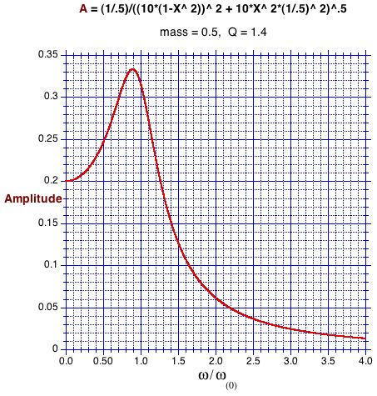
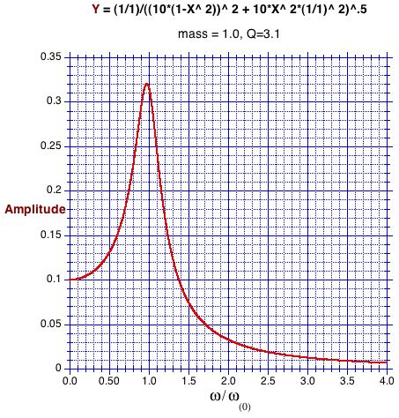
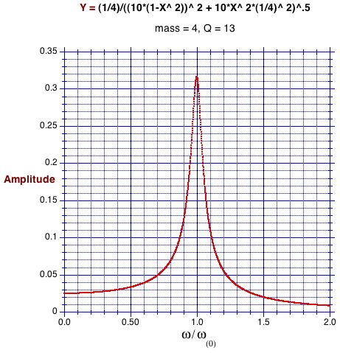
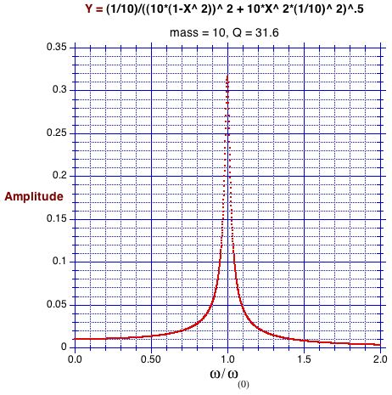

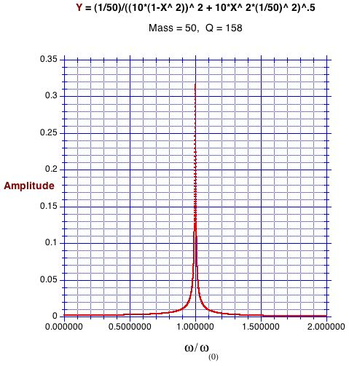
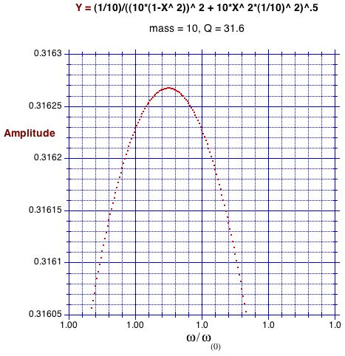
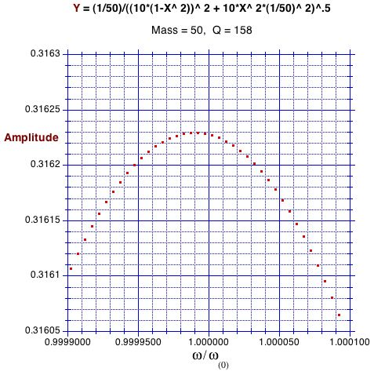

The last two, above, with an expanded scale, show that even with a Q of 158 the maximum amplitude is not yet at the natural frequency. Note also, the difference in their amplitudes.

Notice: As the mass increases, the maximum response approaches, asymptotically, the natural (undamped) frequency, and the maximum amplitude to . This amplitude is found by substituting the amplitude resonance frequency:
- for the driving frequency in equation (2), and, thereby, obtaining:

- for the amplitude at resonance.

Horologically, this is of interest only to confirm the well known fact that increasing the bob’s mass does not measurable change the amplitude, because no “decent” clock has a pendulum’s Q less than several hundred. That the usual clock’s pendulum is impulse driven is, I think, irrelevant, because such pendulum driven behavior is quite similar, as found using Laplace or delta function methods. All the above also applies to RCL electrical oscillators, as its equation has the same form with the substitutions: q (charge) = x (displacement), (current) = (speed), L = mass, 1/C = spring constant (stiffness), R = damping coefficient (b), and drive force emf = . It is understood that for the pendulum the small angle regime applies, k/m is replaced by g/L, and the dissipation is linear. However, many clock pendula’s in their trajectory include a quadratic regime. I suspect that the above is approximately true for that regime, as the linear and quadratic dissipations amplitudes, are rather similar, as the graph below shows.

Bernard Cleyet

http://www.cleyet.org/

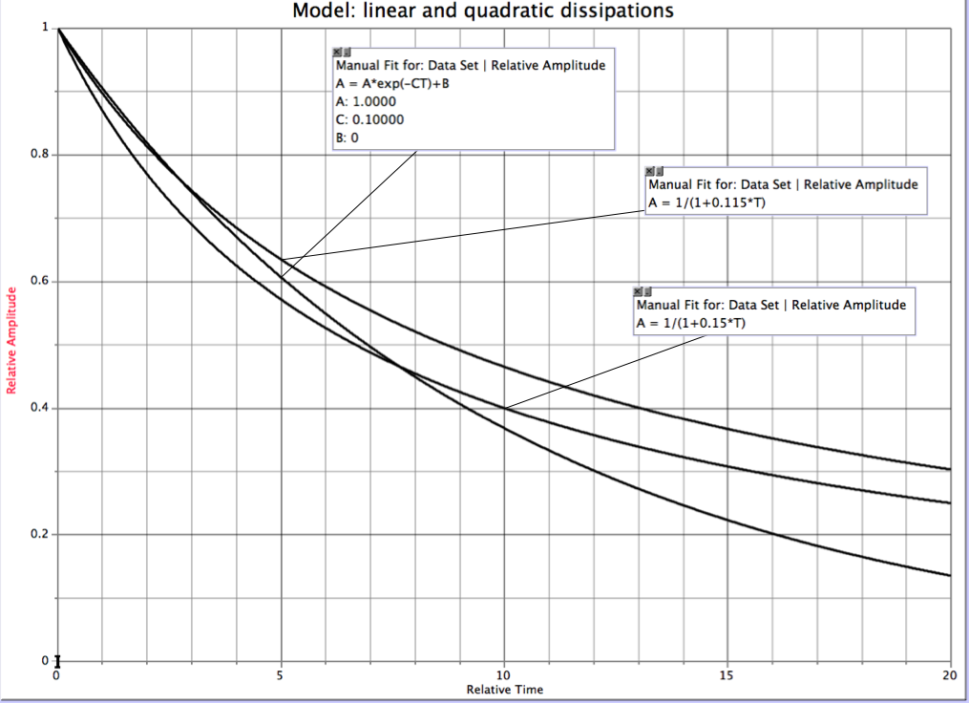

Thornton | Marion, Classical Mechanics, fifth edition, p. 118, equation (3.52)
loc. cit. equation (3.59)
op. cit. p.121, equation (3.64)
op. cit. p. 120 equation (3.63)
Baker and Blackburn, The Pendulum, pp. 37 ff. Green’s method: Thornton | Marion section 3.9

