Q Calculation from Time at BDC of a Pendulum
(as measured by a photo-gate or similar time detector)

Because the speed squared of a pendulum at BDC is proportional to its total energy, Q is easily calculated. The following method is considerably better than the conventional horological method (free decay), because it is quasi-continuously determined.

The basic definition of Q is, verbally:

Two Pi times the total energy of an oscillator for a given cycle or period divided by the energy lost during that cycle or period of oscillation.

When the time a moving pendulum interrupts a light pencil or is otherwise detected present in a given small space centered at BDC, the formula for Q is:

[2Pi / (t(n))^2 ] / [ (1 / (t(n))^2) - 1 / (t(n+1))^2]

Where t(n) is the time for any cycle at BDC and t(n+1) is the next.

or simplified:

~ 6.3 / (t1 * t1) ] / [ (1 / (t1 * t1) – 1 / (t2 * t2)]

The derivation:

The total energy of the pendulum at BDC is its kinetic energy or one half its bob’s mass times it’s speed squared. The speed is the ratio of the distance it travels (detected presence) and the detected time.
It is readily obvious that only the times are necessary as all the constant factors cancel. This is indeed fortunate, as it is difficult to determine the center of mass of a physical pendulum, etc., or measure its speed. Parenthetically, this method is independent of the source of the pendulum’s dissipation.

The following figure is a graph of the Q of Mr. Mumford’s Synchronome, data kindly supplied. Necessarily for the access to the sensor the door was ajar, which explains some of the jitter and variation. The Q values result from averaging 50 points. The data was collected some time after the pendulum was released.

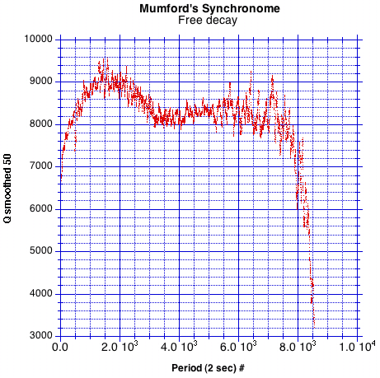

For example, the Mumford Micro System’s MicroSet.
Bottom Dead Center or the undeflected position. I suspect, with out much thought, that any position will do, as long as the pendulum passes the sensitive space of the detector.
Unfortunately, there are two conflicting factors determining the accuracy and resolution of the time. A wider space will reduce the importance of jitter, but may result in a systematic error, because the total energy is kinetic energy only at BDC. Fortunately, the rate of change of KE near BDC is low, (It is proportional to the cosine of the deflection angle.)
Greater accuracy, consistent with the rate of decay, may be obtained by using the average of a number of periods centered about the numerator’s period. Jitter may also require this or otherwise averaging of the data.
More accurately, the pendulum’s moment of inertia times one half it’s angular speed squared. This, however, as noted, does not change the formula.
Parenthetically, the speed is proportional to the amplitude (with in the small angle approximation), so relative amplitude may be found concurrently. For an absolute measure of amplitude one must calibrate from either a known value of amplitude or, height of the center of mass.

