Mr. Heldman’s Apparatus, Quantitatively

In a previous Horological Science Newsletter, [2007-5], I reported my intention to purchase the apparatus necessary to roughly duplicate Mr. Heldman’s new experiment, [2007- 4]. I have purchased the necessary apparatus, and conducted a number of experiments. I’ll discuss only those that relate to pendulum damping due to support compliance, resonance, and a Coulomb friction caused flip-flopping or “jerking”.

Apparatus Description:

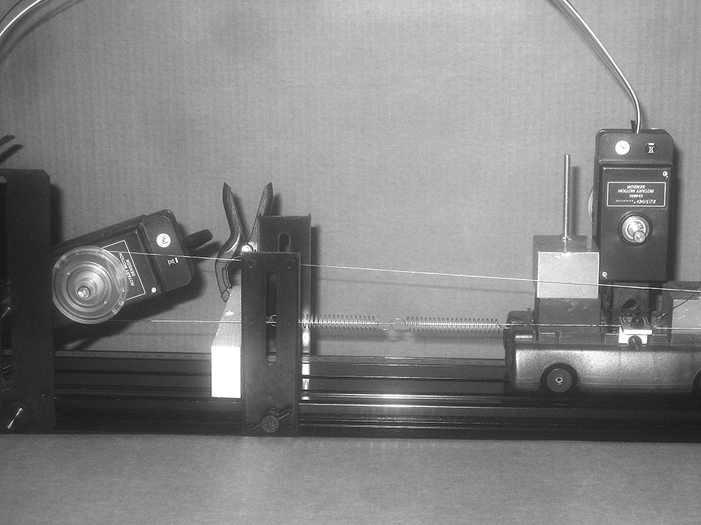
The apparatus, not as rugged as Mr. Heldman’s, is pictured (Figs. 1, 2, and 3.) below in a resonance configuration. The total cart mass is ~ 4.9 kg, and the spring constant 200 N/m. This results in the isolated natural period of ~ 0.98 s. The resonating pendulum (pictured Fig. 3.) has a bob mass of 0.15 kg. I was limited to this maximum, as the pendulum accessory included only two, set screwed brass, cylinders of 0.075 kg. Both degrees of freedom are rather accurately measured by Rotary Motion Sensors (optical encoders). The left RMS measures the cart’s position, and is calibrated in mm (resolution ~ 0.1 mm), while the right, as the pendulum’s suspension, is in radian, (resolution ~ five milliradian). The right cart (Fig. 2.) has attached, by two integral magnets, the adjustable Coulomb friction pad, unfortunately obscured by the pulley bracket. The two carts are locked together by two pair of mutually attracting magnets. The Q of the pendulum, with the PasCar on wood blocks, varies as a function of the amplitude
similarly to that of a Synchronome. (See Fig. 4.) Fig. 1. (Left)
I think the Q is initially low due to nonlinear
(atmospheric) drag. With decreasing amplitude, the Q increases as the drag approaches linearity. The relatively constant region is characteristic of linear damping. The Q then decreases due to the increasing dominance of support, and Coulomb friction dissipation (constant). The initial curious oscillating pattern is due to support oscillation normal to the pendulum’s plane. Mr. Munford’s Synchronome also exhibited this behavior. A very short, five cm, rod pendulum did not obviously exhibit this behavior. I calculated the Q every cycle and did not box average. See the article in HSN 2007-4 for my method. The rod length was approximately 0.32 m. Similar behavior was evident with the resonating rod length of approximately 0.23 m.
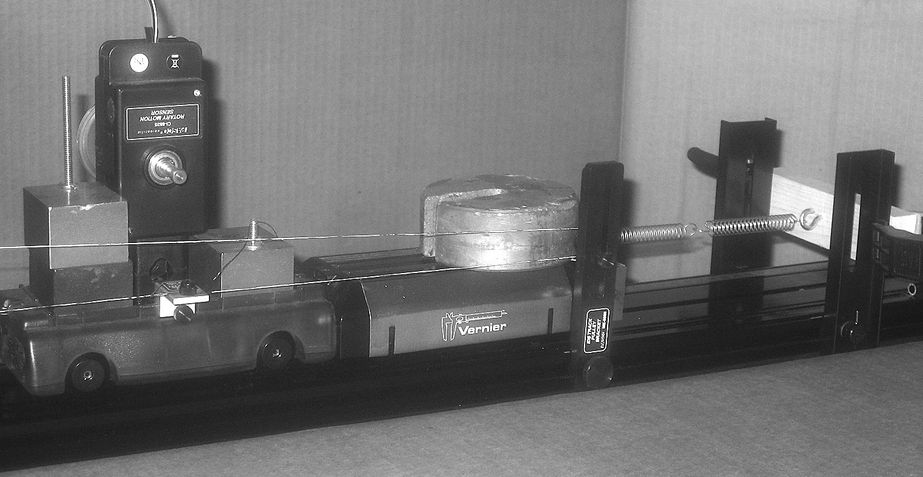

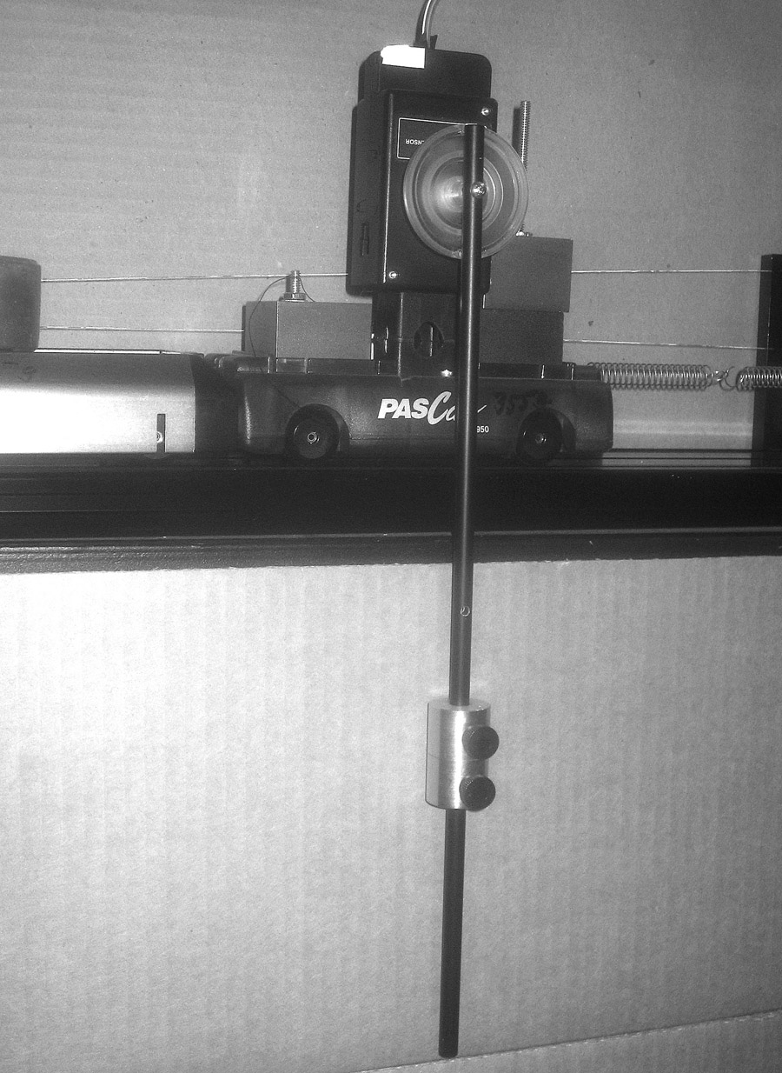
Fig. 2. (Right)

Because the apparatus is rather crude, I found it necessary to use, for those accustomed to clock pendula, extreme initial amplitudes. Therefore, I include a graph of Pendulum Q as a function of the amplitude, so they won't be misled. Vide Fig. 5. Its data is from the same trial as in fig. 4. A discussion of the cart’s Q completes the apparatus description. Its Q is just sufficient to explore the effect of a damped oscillating support, and, with sufficient added friction a flip-flop behavior. As stated above, I obtained from Vernier an adjustable friction pad that adds approximately constant coulomb dissipation. The next figure (Fig. 6.) is a graph of the cart and pendulum support freely decaying as a spring oscillator with the pad screwed up from the track, i.e. it is not driven, as the pendulum rod was removed. Note that the maximum Q is approximately 80, and the cart system’s position is measured in millimeters. The initial amplitude is the maximum possible, the right spring being just unstreatched. The PasCar only, with the RMS, has a somewhat higher Q, and the addition of the thread driven RMS as a linear position sensor reduces the Q by approximately ten percent. Unfortunately, they are both necessary for data collection and the addition of damping. Without the photogate, the highest time resolution of the RMS, using the Vernier LabPro computer interface, is ten milliseconds, quite adequate for the experimental parameters
used. However, with the photogate it’s limited to Fig. 3.
100 milliseconds. This limitation is obvious in figure six.
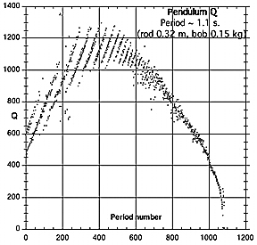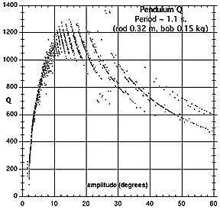

Fig. 4. Fig. 5.

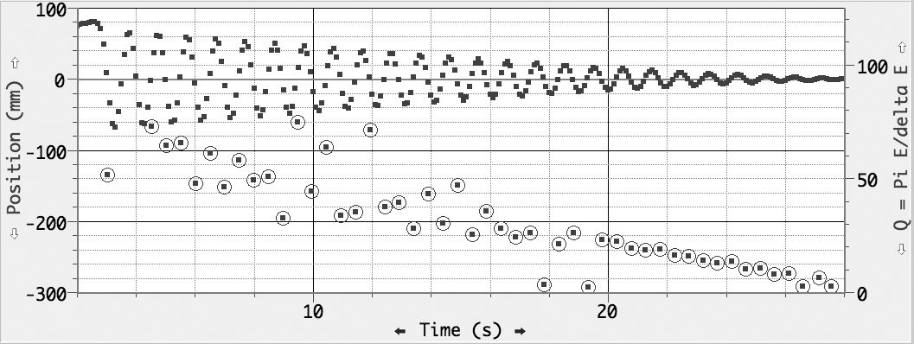
Fig. 6.

The following figure (seven) illustrates the energy transfer from one coupled oscillator to another when their natural frequencies are approximately the same. The oscillations were initiated by displacing the pendulum approximately 1.3 radians (75 deg.). The data with respect to energy is internally consistent, i.e. the potential energy of the pendulum is approximately the same as the spring’s at their maximum displacements (~ 0.24, and 0.19 Joule, respectively). The difference is easily explained by the cart’s dissipation during the two plus cycles necessary for the complete transfer. Note that nearly all the initial pendulum’s energy is dissipated in approximately 25 cycles, and the dissipation rate decreases with amplitude. You will note that after about 36 seconds the pendulum decay is much reduced, because the cart is now semi-locked by its static friction. “Semi” because of a system lash revealed by expanding the cart’s position ordinate. This continues for some time and is about 0.1 mm. Notice, also, that, though the cart and pendulum’s total initial energy is one fourth that of the cart in Fig. 6, the decay times (number of cycles) are approximately the same for an obvious reason. As is obvious from the graph, I manually displaced the pendulum not using the time honored match and thread method. In addition, I didn’t restrain the cart while displacing the pendulum.
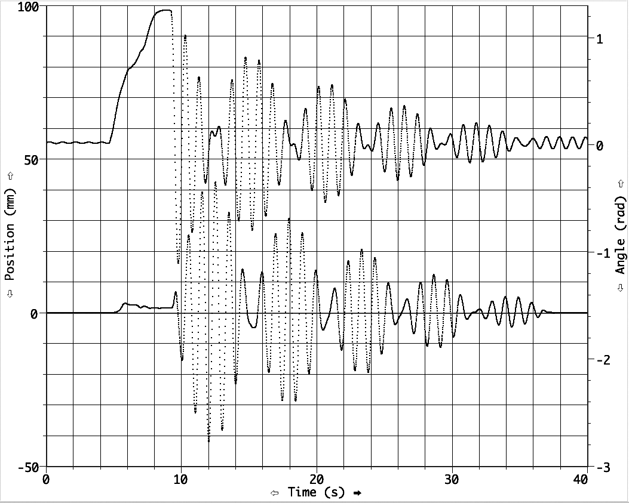

[Upper curve, right axis] Fig. 7.

The next figure illustrates the incomplete transfer of energy when the natural frequencies differ significantly. Fig. 7’s periods are ~ 0.98 s., while fig. 8’s pendulum is ~ 1.5 s. Though the initial pendulum displacement, is ~ 70% that of Fig. 7’s (0.9/1.3), the initial energy is about twice (0.3/0.17), because the rod’s length is about double (~ 0.55 m), limited by the height of the coffee table). Therefore, despite the greater pendulum energy, significantly less is transferred. Note the initial rapid decay of the cart’s natural frequency (~ 0.98 s.). However, a beat modulation of the cart driven at the pendulum’s period (~ 1.5 s.) is still noticeable after a minute. This behaviour is similar to that of my numerical model. [Fig. 4, HSN, 2007-5. p. 34] except, of course, it continues indefinitely as I didn’t include a damping term in the spring oscillator’s differential equation. However, my Fig. 7 (op.cit.) shows this behavior for a damped spring oscillator driven out of resonance. Because the pendulum has a very high high Q compared to the cart’s, it acts as a quasi-sinusoidal drive of the spring oscillator cart, hence the similar behavior.

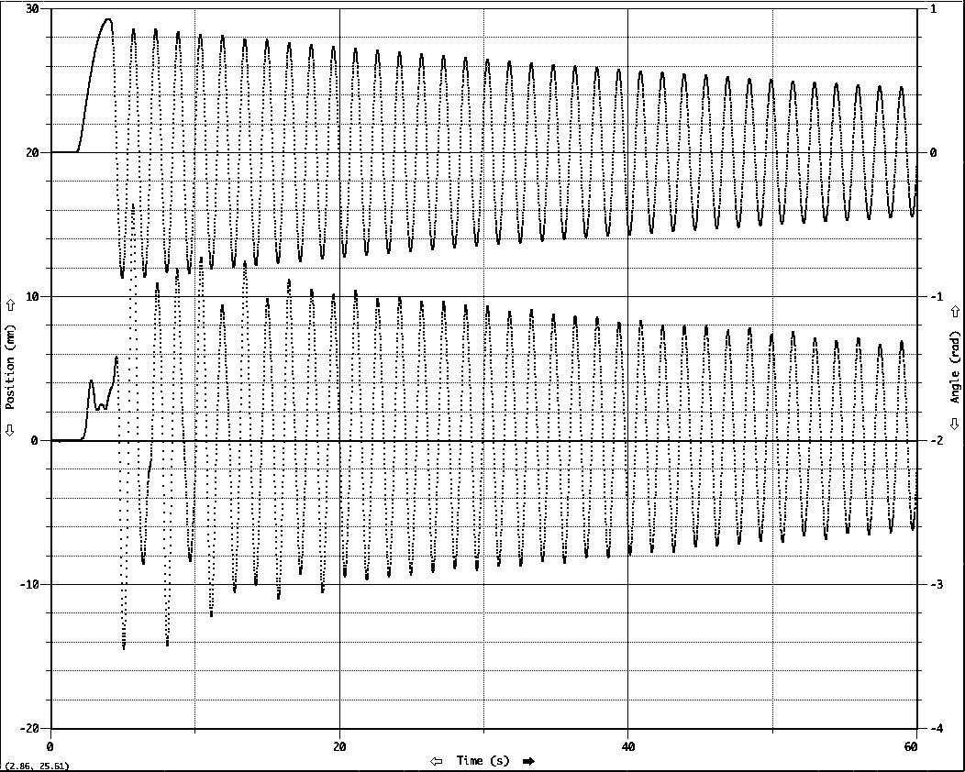

Fig. 8.
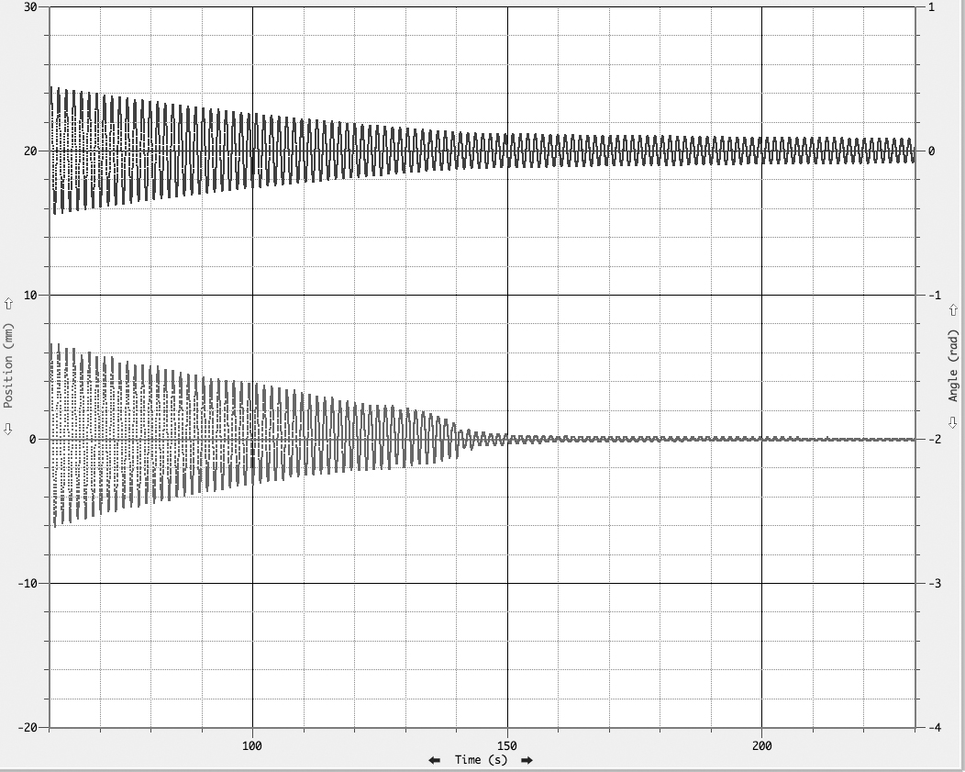

Fig. 9.

I have included a graph of the end of this coupled oscillator’s decay (Fig. 9.) to reinforce the familiar fact that when the suspension becomes semi-locked the pendulum’s Q increases significantly. This is evident in Figs. 7, 13, and 15, also.

Finally, we examine the effect of much increased cart damping.

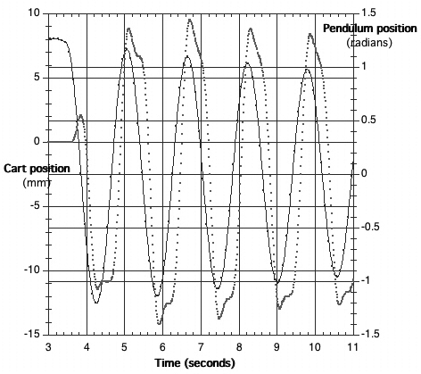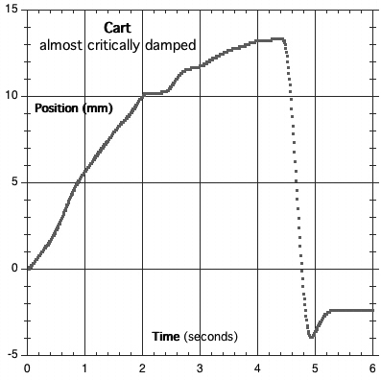
Fig. 10 Fig. 11.

Figure 10, above, shows the effect of increasing the damping to what, if the damping were linear, would be termed approximately critical. With linear damping, for all initial displacements, the oscillator decays to zero displacement just without overshoot (oscillation). In the case of constant damping, the behaviour will, with a small displacement, act as if over damped, and with a large displacement, will oscillate. The damping in the above case was approximately “critical” for that trial’s initial displacement. Figure 11 shows this almost critical cart damping. With decay, damping becomes “over critical”. Figure 12 is the complete trial shown in figure 10. Notice: in figure 10 both the phase relation of the pendulum, as it drives the cart, and the cart’s hesitation (nearly flip flopping) due to friction. With increased friction, figure 13, the oscillator “flip flops”. This oscillator is initially “over damped.

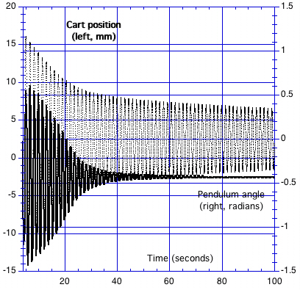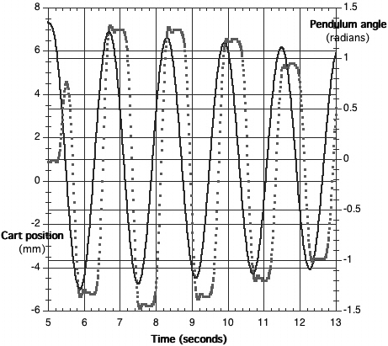
[Upper curve, pendulum] Fig. 12. Fig. 13.
Figure 14 shows the corresponding over damping of the spring oscillator, and figure 15 the complete trial. Note the interesting shape of the envelope (maximum amplitudes) of the two heavily damped spring oscillators’ curves. Initially it is linear (straight) and then curves (approximately exponential). This is most evident in figure 12, nearly absent in 15. I think this is due to the dominant constant dissipation (Coulomb damping). At about 25 seconds (figure 12) the proportional absorption of the pendulum’s energy becomes much less, because the dissipation duty cycle is low, i.e. the cart spends a longer proportional time “locked”. Therefore, the pendulum acts as a more nearly constant sinusoidal drive. With the cart mostly locked, the dominant dissipation is linear and the system exhibits exponential decay.
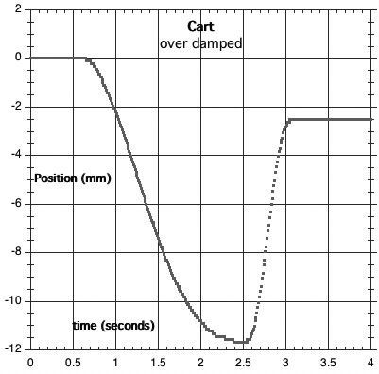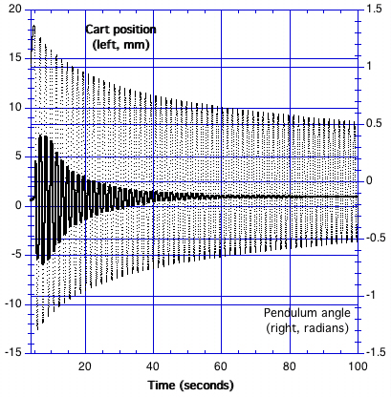
Fig. 14. Fig. 15.
I have found, numerically and on a gross scale experimentally, the behaviour of a non-rigidly supported pendulum. In particular, if there is resonance, the pendulum will exhibit a “beat” behaviour. The beat intensity is a strong function of the difference between the oscillators’ periods. Resonance or not, the pendulum Q depends on the damping or rigidity of the support. The latter, of course, is quite familiar. Finally, because the springs in Mr. Heldman’s photo [HSN 2007 – 4, p. 22] appear nearly fully stretched, I suspect the oscillators flip-flopping is due to their resulting hardness. I hope to duplicate this for my next article. I also hope to examine support rigidity and pendulum period. bernardcleyet@redshift.com

He informed me that he wouldn’t be able to continue his experimentation for some time, so I have thought myself free to continue where he “left off”.
Vernier Dynamics System [track, low friction cart, masses, plus an adjustable cart friction pad], and two rotary motion sensors. From Pasco: pendulum and linear motion accessories. I already had the LoggerPro interface.
The attachment of the RMS to the cart is far from ideal. I milled the plastic edge (Dremel tool) to accommodate the mount and welded it with PVC pipe solvent. Furthermore, the cart’s wheels have considerable lash.
Data for figs. 4 and 5 were collected using the MicroSet (Mumford Micro Systems) and its included standard optical sensor. The dominant source of jitter evident in all the graphs is likely due to the crudeness of the apparatus, and the external environment (draughts, etc.) The Kaleidograph application was used for the analysis and some of the graphs. Fig. 6 and some of the following graphs were generated by Logger Pro, Vernier’s analysis application bundled with the LabPro computer interface.

